**VIRTUAL NETWORK**

**Create a virtual network**

1. On the upper-left side of the screen, select **Create a resource** > **Networking** > **Virtual network**.
2. In **Create virtual network**, enter or select this information:

| **Setting** | **Value** |
| --- | --- |
| Name | PKvnet |
| Address space | 192.168.1.0/24 |
| Subscription | Pay-As-You-Go |
| Resource group | Select **Create new**, enter*PKGR*, then select **OK**. |
| Location | **East US**. |
| Subnet - Name | Frontendsubnet |
| Subnet - Address range | 192.168.1.0/24 |

1. Leave the rest of the defaults and select **Create**.

**Now create backend subnet using PKRG resource group**

| **Setting** | **Value** |
| --- | --- |
| Name | PKvnet |
| Address space | 192.168.1.0/24 |
| Subscription | Pay-As-You-Go |
| Resource group | Select **Create new**, enter*PKGR*, then select **OK**. |
| Location | **East US**. |
| Subnet - Name | backendsubnet |
| Subnet - Address range | 192.168.2.0/24 |

**Create resource group**

**FRONTEND AND BACKEND IMAGES**

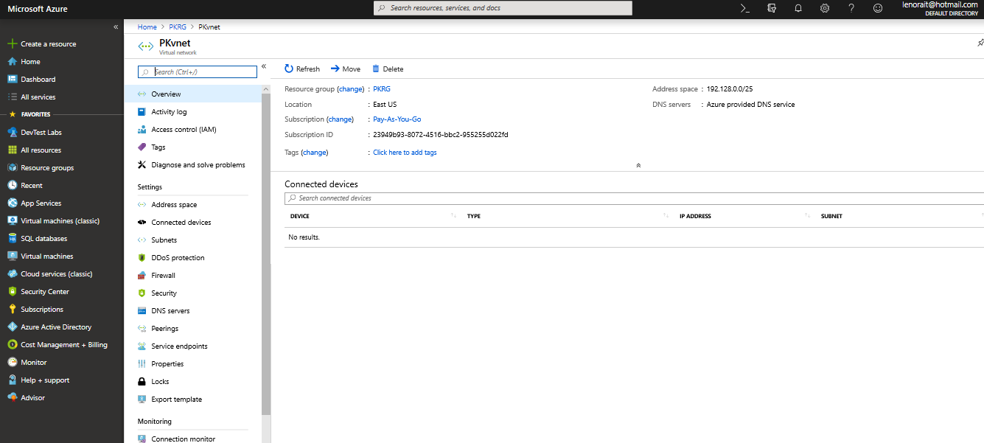

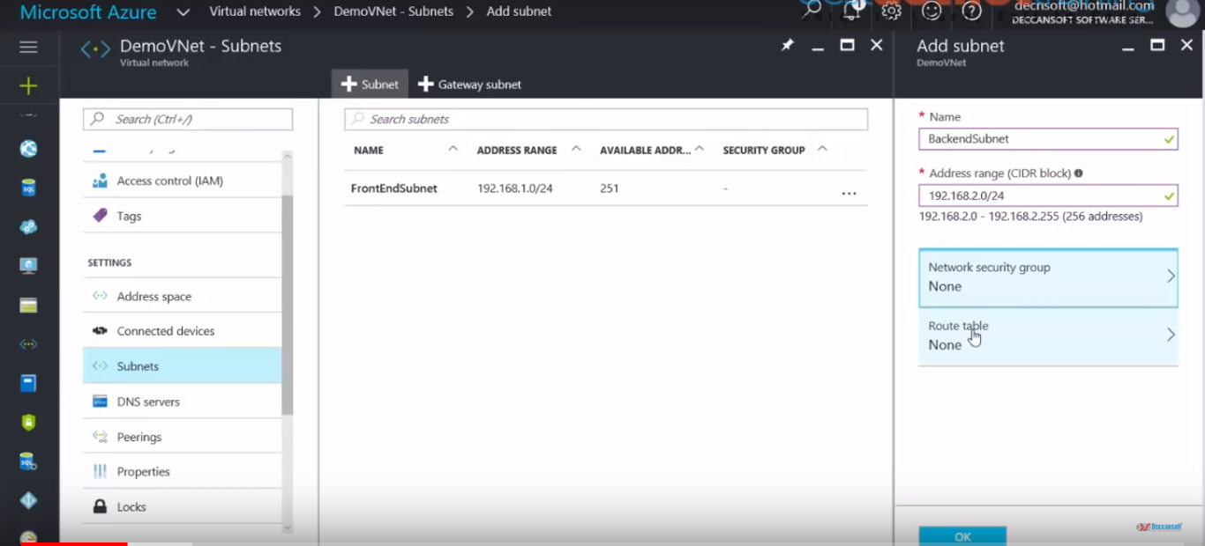

**Create NSG rules for front and backend vnet**

**NSG-FRONT END: - the frontend nsg rule will applied to front end subnet and contain two rules**

**Rdp rules** this rule will applied to RDP traffic the front end subnet.

**Web rule** This rules will applied to HTTP traffic to the front end subnet.

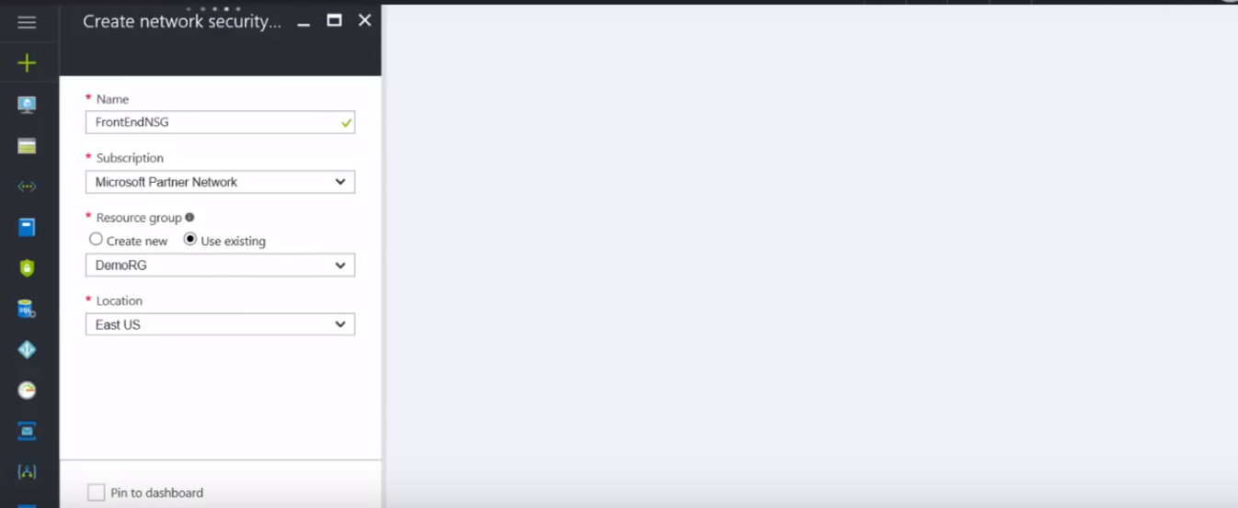

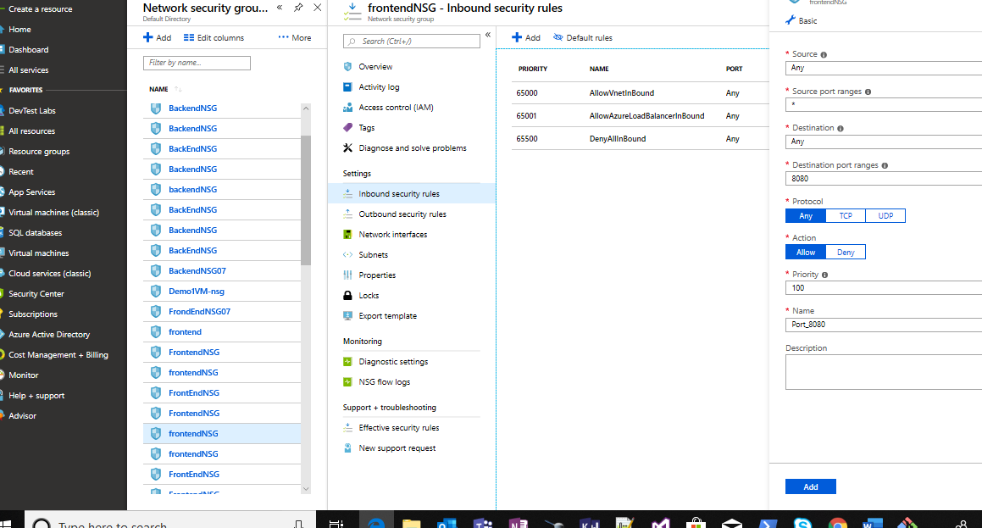

**NSG-BACK END: - the backend nsg rule will applied to front end subnet and contain two rules**

**SQL-RULES** This rule will applied to SQL traffic only from the front end subnet.

**WEB-RULES** This rules will denies all internet bound traffic from the backend subnet.

